MD CT Sim and Plan Order Write-up (and eSCRIBE Walkthrough)

1. In MOSAIQ, go to eChart > Documents.

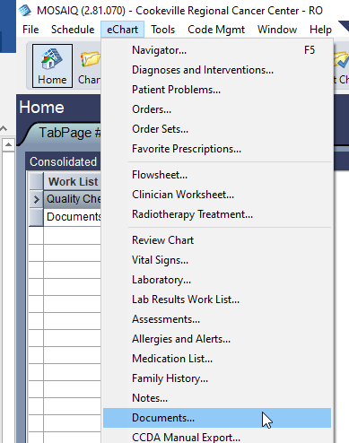

1. Click Add > eSCRIBE.

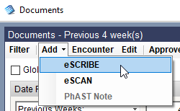

1. Set the Document Type to MD- CTSIM & PLAN ORD and the dictator and transcriber to the MD. Set the encounter date and transcribed date to the date of the procedure. Click Edit.

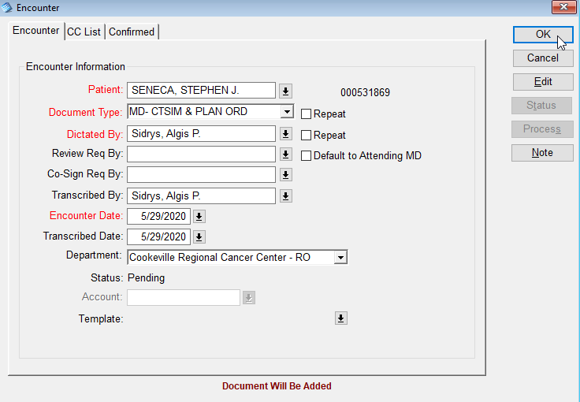

1. Select Physician’s Orders.dotx in the Physician’s Orders folder.

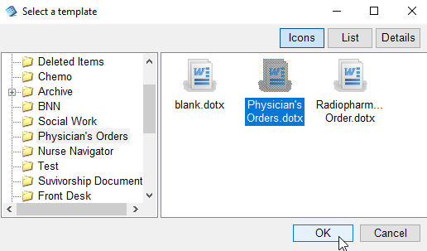

The document will open in Word.

1. Fill out the form.
2. Go to the Add-ins tab and click OK.

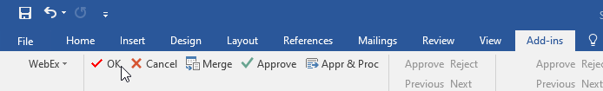

You will be taken back to the Documents list.

1. Highlight the new document (should be the last item) and double-click to view. Check that it is correct and close the Documents window.